1. **Set Up Virtual Environment**

First, ensure you have virtualenv installed. If not, you can install it by running:

1. Create a Virtual Environment

Navigate to your project directory and create a virtual environment:

This will create a venv folder inside your project directory.

1. Activate the Virtual Environment

I am using Ubuntu so run **source** **venv\bin\activate**

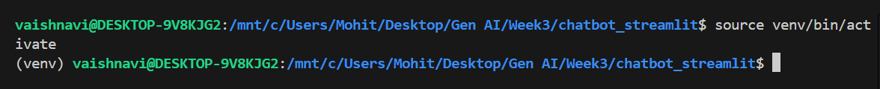

You should now see (venv) in your terminal, indicating that the virtual environment is active.

1. Install Dependencies

Once the virtual environment is activated, install the dependencies from the requirements.txt file:

1. Set up environment variables:

1. Deactivate the virtual environment (when done) using **deactivate**
2. **Main Application Code**

After all the requirements are installed and virtual environment is set, lets move with the creation of chatbot using gpt-4o-mini model and streamlit.

Running the Application

To run the Streamlit app, use the command: **streamlit run chatbot.py**

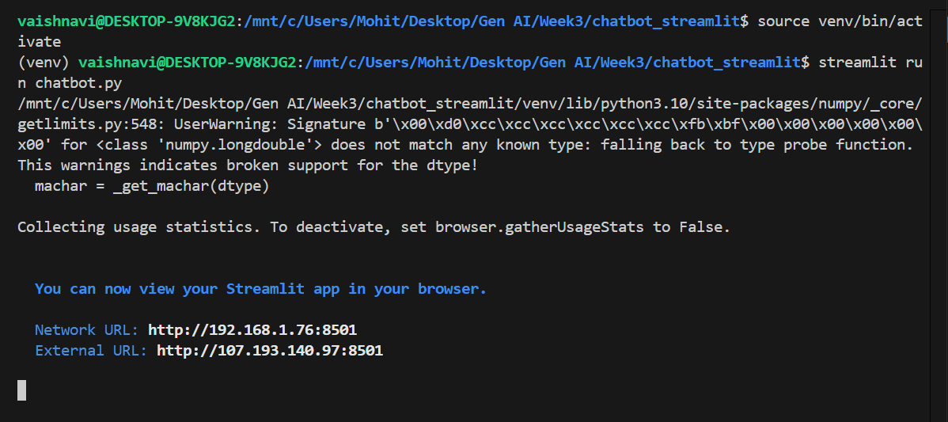

Then follow the link shown

